Class Diagrams:
- FacebookBackEnd:
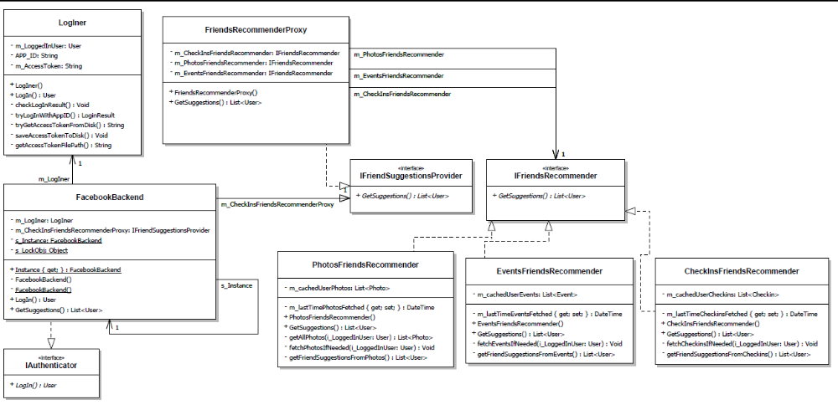

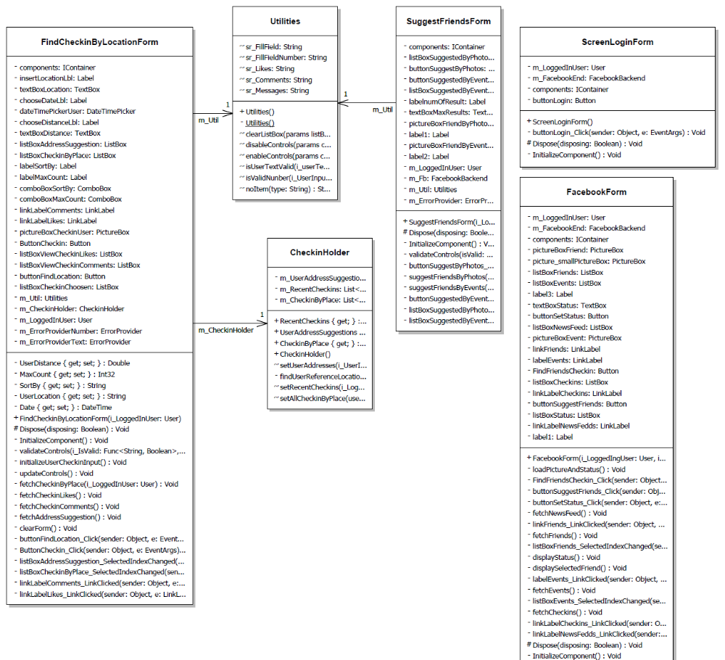
- FaceBookFrontEnd:

- FundTagsAround:
